Prof. Heitor Gurgulino de Souza, IAUP Secretary General Emeritus
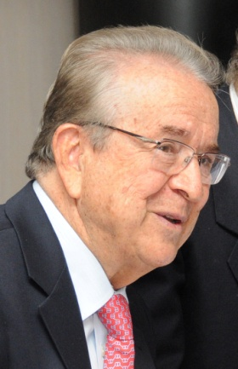
Former Rector of the United Nations University (1987-1997), in Japan and Special Advisor to the Director General of UNESCO, in Paris (1998 1999). Vice-Rector of UNILEGIS (University of the Brazilian Legislature), Federal Senate, Brasilia (2003-2005), Vice-President of IAUP- International Association of University Presidents (1999-2002), Member of its Executive Committee and Secretary General (2008-2011).Elected Secretary General Emeritus, from 2011. He received a BS (1949) and Licenciado (1950) Degree in Math/Physics from Mackenzie University, São Paulo, Brazil. Has specialization courses and did research work in Nuclear Physics and Solid State Physics at ITA/ Brazil (Aeronautical Institute of Technology - where he was an Instructor and Assistant Professor) (1951-1957), at the University of Kansas/USA and at the University of São Paulo. Since 1958, was Professor of Physics at UNESP at its Rio Claro Campus, in São Paulo, Brazil.. During 1962-1969, worked at the Scientific Department of the OAS(Organization of American States) in Washington, USA, and helped organize a large program on S&T Development for Latin America. In 1970, was first Rector of the Federal University of São Carlos, São Paulo, Brazil. From 1972-74, was Director, Department of University Affairs, Ministry of Education, in Brasilia. For 12 years (1974-1986) by Presidential appointment, was a Member of the Federal Council of Education of Brazil (Vice-President during 1985-1986). From 1975-78, was Director of CNPq (National Research Council), in Brasilia and from 1974-77, was Chair of the Inter-American Committee on S&T of the Organization of American States, in Washington, DC.
Was a Member of the ICED (International Council for Educational Development), Princeton, USA . President of the Latin American Interuniversity Group (GULERPE), in Caracas, Venezuela and in Brasilia, Brazil. Was Chairman of the Board of LASPAU ( Latin American Scholarship Program of American Universities), Harvard, USA. Member, since 1997 and Vice-President of the Club of Rome (2006-2012), Member of the World Academy of Arts and Science(WAAS) ; Member elected of the Brazilian Academy of Education since 2002, Member of the Brazilian Society for the Progress of Science since 1961; of the American Physical Society since 1956 and of the Brazilian Society of Physics, since its founding. Honorary President, Virtual Educa, Spain and Latin America, since 2004.
Professor Gurgulino holds many Doctor Honoris Causa degrees (from Universities in Brazil, Mexico, United States of America and Japan), Professor Emeritus of the State University of São Paulo (UNESP) in 2008 and is the author of many articles in the fields of physics, teaching of physics, applications of S&T to Development, University administration and on United Nations issues and Editor of a book on “Science Policy” in Brazil.

