Lecture 2:
Social, Political, Constitutive Process

Winston P. Nagan
Garry Jacobs
With the assistance of Madison E. Hayes.
I. Introduction

- This lecture seeks to provide clarity about the role, function, and understanding of law in the context of society. If one were to ask an ordinary layperson what he thought law was, he would have some confidence in suggesting that it is composed of rules established by the community to define right from wrong. More than that, the wrongdoer is liable to be punished and the doer of right is likely to be rewarded. But when the layperson is challenged about the origin, interpretation, and efficacy of the rules, or the notion that there may be other formulations that guide human conduct and that involve human agency, the confidence in what the layperson presumes to be law begins to evaporate.

II. What is law?

- One of the greatest challenges of legal theory has been to find a model that adequately explains what law is within the context of human social processes.

- The legacy of legal thinking has been highly influence by the natural law tradition. Natural law has contributed to the betterment of mankind, in particular its emphasis on the role of right reason in the construction and interpretation of law. Though natural law has contributed much, its central weakness lies in the fact that if it is prescribed and applied wrongly, there is no way to test the validity of a wrong interpretation. Only God can change natural law. This led to the skepticism of natural law that it was often “nonsense built upon stilts.”

- Modern science stressed the idea that law should instead be expressed in scientific terms. The most obvious form of science, analogous to mathematics, was logic. Hence, the powerful view that jurisprudence is the formal science of positive law, one of the earliest versions of positivism.

- A later version of positivism sought to root law in actual decision-makers in human society. Oliver Wendell Holmes, a Justice of the Supreme Court of the United States, stressed this different form of positivism, challenging the currency of law defined by logic and insisting that the life of the law has not been based on logic, but experience. This suggestion opened a different pathway to the study of law, which led to the idea that law emerged from the experience of the give and take of human beings in society. The science relevant to understanding law is a science based on social experience.

- The focus on rooting law in social experience led to an interest in seeking to understand law from the point of view of the behavior of participators in society, and of participators in institutions specialized to what is called law. These developments began to demonstrate that an understanding of law could not be contained in a single disciplinary formula. Clearly, law implicated a multitude of disciplines all relevant to a deeper understanding of the human social process itself.

- Working together, two fellows of the World Academy, Harold D. Lasswell and Myres S. McDougal, developed a revolutionary approach to law. Their approach was multi-disciplinary, problem-oriented, goal-guided, decision-focused, and provided a more complete picture of the role of law in the public order of humanity. In their view, what we call law is a response to problems that emerge from the social process of humanity.

III. What are problems?

- These fellows, influenced by the tradition of American pragmatism, began to clarify the idea that law was essentially a community response to the problems that emerged from the give and take of human relationships in society.

- A key to a realistic understanding of law is to understand the problem, which emerges from the social process, to which law must respond in the form of authoritative and controlling decision-making.

- The problem of what a problem is is itself complex and intricately tied in to the nature of social process itself.

- A problem that emerges from the social process is a problem about contested values. By values here we mean things that people desire.

- This means that society itself is intricately implicated in the problems generated by the production, distribution, and conservation of the things people value and desire.

IV. Human Needs and Values

- Anthropologists have long recognized that in traditional, indigenous societies, the social process targets the importance of human needs and determines how those needs are satisfied, acquired, accumulated, and preserved. In this sense, at a very basic level, human needs cross-culturally are fairly constant.

- Contemporary theory began to clarify the universality of human needs and found it convenient to express these needs in terms of basic values necessary to the workings of any social process. The values, like the needs, remain constant, however, in a cross-cultural world, the mechanisms that society invents or develops to facilitate the production and distribution of needs/values reflects cultural variability.

- It is, therefore, not the values that differ cross-culturally but the institutions communities invent to produce, distribute, and conserve the desired needs/values in the society.

- Social process starts with the individual human being. The individual human being comes with a human perspective which includes the perspective of identity, the perspective of demands for values, and the perspective of expectation. How does this translate into the social reality of human interaction driven by the energy of human personality and aspiration? Let us begin with an illustration.

- One of the most important outcomes of any social process is going to be the problem of needs and value conflicts and how these are resolved. Among the most important of the outcomes of social interaction is going to be the interrelationship of conflict and the processes by which conflicts in society express themselves. We can call this the power process. What energize the power process are the claims in society that people make about the shaping and sharing of power. If no one ever made power claims we would have a static society. The claims to power are largely generated by the social activists, a personality type oriented to power.

- Consider for a moment an ordinary case of a claim to power in the civil rights movement. Rosa Parks, a black woman, came from a group largely disenfranchised. This meant many forms of discrimination, including discrimination in public transportation. Her claim to power came when she refused to be seated in the back of a bus. She challenged the power of the state to discriminate. In many ways, this single act was a launching pad for the modern civil rights movement in the United States to have segregation dismantled.

- Let us take another example: Mahatma Gandhi was an Indian lawyer travelling to a client in South Africa when he was removed from a train because he was not white. From there, Gandhi launched a claim to challenge racial prejudice targeting the Indian community of South Africa. He launched the famous passive resistance campaign to protest unjust laws. He later became the leader of the Nationalist Movement in India, challenging the authority of the British Empire.

- One final example may suffice. Nelson Mandela challenged the power of the apartheid state. In his trial, he gave a famous speech in which he said that his political ideals were democracy and human dignity. It was these ideals, he said, for which he was prepared to die. He later became the President of South Africa and drafted its first Freedom Constitution.

- In short, an understanding of the power process, an understanding of the need to express power claims and demands, and the strategies to act on them utilizing bases of power available to the actor provide a realistic description of the dynamics of the power process in any context.

V. The Social Process

- With this background, it becomes apparent that society cross-culturally is actually a dynamic social process. To understand this social process is to understand the foundations of law and legal culture as well. First, we must have a formulation to describe any social process at any level of abstraction that is applicable globally and cross-culturally.

- The WAAS fellows focused on this issue were Harold Lasswell [former president of WAAS], Myres S. McDougal [fellow], Michael Reisman [fellow], Richard Falk [fellow], Burns Weston [fellow], and Gary Brewer [fellow].

- What emerged was the following formula, used to describe any social process and whose markers permit the extrapolation of social process to elevated levels of inclusivity and precision. According to these theorists, the social process is comprised of human beings who pursue values/needs through institutions based on resources.

- This succinct description of social process resembles the brilliance of Einstein’s formulation E=mc².

- Phase-Analysis: Mapping the Social Process

- In order to extrapolate upon this model of social process to any level from the micro to the macro-social context, these WAAS theorists developed a set of markers to guide the inquirer. These markers were described as the tools of phase-analysis. They are as follows:

1. Participants
2. Perspectives: identifications, demands, and expectations
3. Bases of power: power, wealth, respect, skill, health and well-being, affection, enlightenment, rectitude, and aesthetics [all values can serve as bases of power or as desired values to be acquired]
4. Situations: geographic, temporal, institutional, crisis,
5. Strategies: coercive or persuasive, such as diplomatic, ideological, economic, or military strategies
6. Outcomes: production, conservation, distribution, and consumption
7. Effects: longer-term effects on value production and distribution

- The first marker identifies the human participators in social process. This is an important beginning point of description and analysis. The identification of human beings as the foundation of the social process is also a current approach to this issue by the World Academy.

- The second marker identifies the psychosocial perspectives of the participators including the sense of who they are, what they want, and what expectations they may hold. For example, every human being has a pattern of identity rooted in psychosocial experience. Every human being will make demands for basic values and needs as reflected in power, wealth, respect, skill, health and well being, affection, enlightenment, rectitude and aesthetics, and every human being will temper both their sense of identity and their demand for values via the process of adaptation to community expectations.

- The third marker deals with the bases of power available to social participants. These include the fact that social participants may already have access to values and may use those values as bases of power to acquire more of the values of society. Additionally, law, the system of authority that facilitates and defends the processes of value production and distribution may also be a base of power available to participators.

- The fourth marker addresses the various situations that may influence a participant’s ability to acquire, produce, or distribute values. These situations may be either advantageous or deficient. These situations include geography (territorialism) and temporality (time as a constraint on human action), the efficacy of institutions, and the circumstances of crisis

  - Geography is reflected globally in the territorial integrity of nation-states. Geography is reflected in the reach and application of law in which territorial boundaries prescribe the reach and limits of law.

  - Temporality reflects the relationship between events and the duration of time. Time affects human interaction in terms of the scope of duration. Human beings have a limited time span of life. Artificial persons such as corporations or states transcend the lives of their human creators. In this sense, human beings use institutions to manipulate the time artifact.

  - Institutions are one the most important mechanisms for the management of the production and distribution of values in society.

    - For example, there may be institutions of governance that manage the problem of power in society.

    - There may be institutions such as corporations and banks that promote the development of wealth values and their management and distribution, for example through the most elementary forms of association as the principal-agency relationship.

    - Enlightenment may be institutionalized in monasteries, temples, churches, schools, universities, etc.

    - Enlightenment sometimes overlaps with rectitude, which may also be allocated to those religious institutions.

    - Health and well-being in traditional society may be institutionalized by the role of the shaman-healer or in modern society by the trained physician.
    - With regard to skill, in traditional societies there would be the institution of training warriors, as in the Spartan culture, although in modern society the transmission of skill is a vastly dynamic exercise.

    - Respect, the way in which the society’s value system seeks to secure the integrity and personhood of the individual, institutionalized through social class distinctions.

    - Affection will usually be managed through micro-social institutions like the family or groups analogous to the family form. Affection, in the form of positive sentiment, is a powerful instrument for political and cultural identification and solidarity.

    - Aesthetics reflect the cultural respect for the creation of idealized forms of artistic expression, institutionalized by specialists in music, painting, and sculpture, amongst others.

  - Finally, situations may partake in the circumstances of crisis, which may overwhelm or undermine geography, temporality, and levels of institutionalization.

- The fifth marker identifies outcomes, the immediate identification of the value problems in the community. The most important outcomes of all social processes are the problems of value distributions, indulgences, and deprivations. Essentially, a social problem is one in which a participator claims value that is held by another participator or by the community that he believes he is entitled to have.

  - In contemporary terms, what triggers the global human rights problem is the problem of serious value deprivations, so egregious that they are deemed to be human rights violations.

  - The problem of the production and distribution of the value of power is one of the most important outcomes of the human social process.

    - These issues are so universal and so important that it is quite appropriate to put these problems into the context of the community power process, be it localized or global.

    - One of the most important contributions, therefore, that social science can make to the clarification of the distinct problems of power and their management in society is to develop, using the phase-analysis, a description of the community process of effective power.

- The final marker addresses effects, which refer to the longer-term implications of how problems are resolved or not resolved within the community. The effects of the social process reflect the prospects of both stability and contestation with regard to the production and distribution of values. The problems generated by conflict and contestation emerge as the social process generating a discrete sub-process, the community process of effective power.

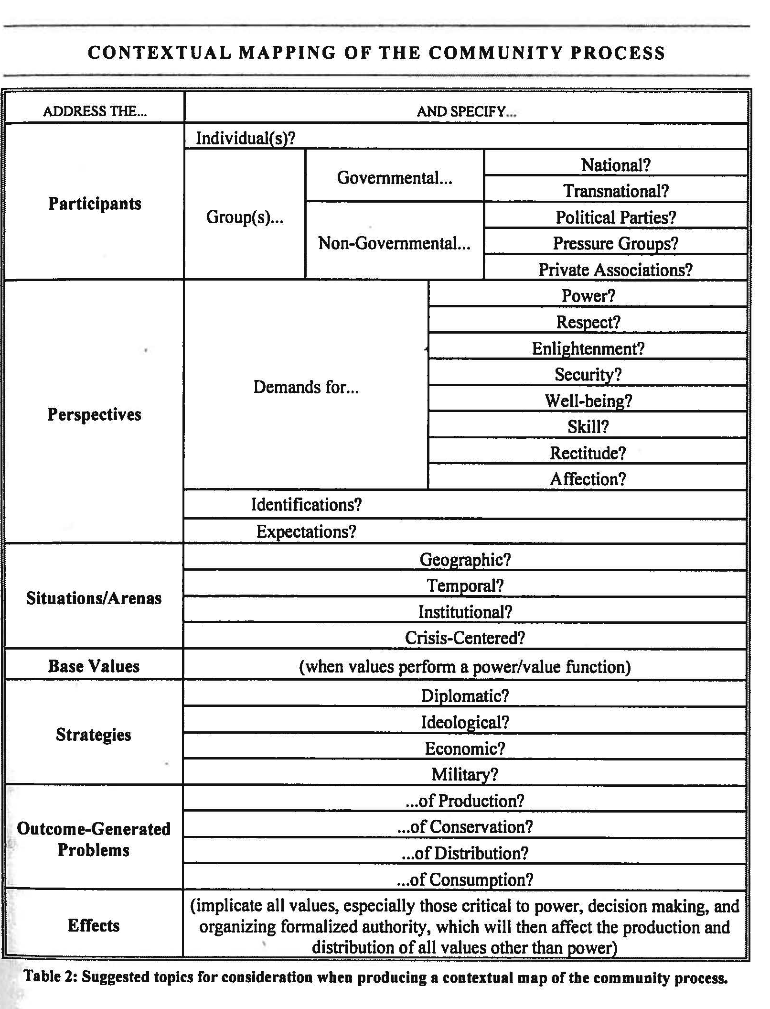
- This map of social process is not meant to be static. It is a dynamic model within which interaction takes place between human beings. The central energizing force of social process is the individual human being pursuing and demanding needed goods and values. This energy derives from the personality perspective of the actor, driven by the imperatives of identity, the needs for needed good, services, and values, and the expectation of stability and change in cultural norms.

- Central to energizing social process are the demands for values which, in effect, are the claims that human beings make as stakeholders in the community process. Claims for change are usually tied to the process of effective power. However, any value can serve as a base of power to acquire any other value. In short, an actor may use power to acquire wealth. An actor may use wealth to acquire power. In the example of Rosa Parks, she is using the value of respect as a base of power to claim civil rights. In the case of Nelson Mandela, he is using respect to claim dignity and political rights. In the case of Mahatma Gandhi, he is using rectitude to claim the truth about the political morality he espouses.

VI. From the Social Process to the Effective Power Process

- The presumption of the notion of community is central to the ideas of social process and law. The term community may mean everything and nothing when it simply refers to human aggregates. However, human aggregates may disclose levels of intensity of interaction in both their perspectives and their operations that transform those aggregates into communities or clusters of communities. In effect, then, the identification of a community is an empirical matter of understanding the social process, which generates both the interaction, interdependence, and the level of inter-determination of the relevant universe of participators.

- One of the most important outcomes of the notion of community at any level of complexity is that community will generate problems relating to the scope and intensity of both collaboration and conflict.

  - It is most important to recognize that the outcome of conflict and its intensity may challenge the coherence and stability of the community. Thus, it is very important for both participators and observers to understand and, indeed, unpack the dynamics that relate to the outcomes of conflict in a community.

  - The outcomes of conflict essentially implicate the problem of power in the community. Some participators may be more skilled than others in acquiring power to control others. This power is normally expressed through the human capacity to make decisions about power relations. The central ingredient of power will invariably be the degree of coercion that the monopolizer of power in the group can deploy via the decision-making process. We may refer to such decisions as decisions made according to calculations of naked power or control.

  - The most important insight into the interrelationship of the social and power processes is that we can radically contextualize power to better understand its place in the social process. For example, if we look at the financial crisis in the US, a major trigger for the financial crisis was the power of the financial industry to leverage the Congress of the United States to deregulate finance. What we need to understand is that deregulation was an allocation of power to the financial industry to be accountable only to itself. This led to the abuse of many of the institutions of finance upon which the economy was based.

  - We may add further illustration. Although the United States has experienced a large number of atrocities using guns, efforts to even minimally control the sale and access to guns have been futile notwithstanding public opinion polls that overwhelmingly favor gun control. Here, it is the power of the gun lobby and the money it can use to control the Congress that prevent rational gun control legislation.

- It will invariably be the case that decisions about the exercise of naked power will be contested by those who wish to themselves have recourse to power and influence in the community. This means that community conflict, which may involve violent, coercive confrontations, is an omnipresent condition in a community in which the public order is maintained by naked coercion.

  - Such conflicts may result in a winner and a loser. The winner will doubtless continue to rule from the perspective of expedient naked power considerations. Although, even if there is a clear winner, the seeds of conflict may not be entirely extinguished. Conflicts may continue and be sustained by the awakened consciousness of society that resists rule by naked coercion and insists on more enlightened criteria and accountability for the exercise of power in the community.

  - The contestations for power may ultimately lead to a stalemate, with each side recognizing that the continuance of conflict means net losses for both contestants. Here, an enlightened spark infuses the germ of self-interest into the contestants. They may well consider allocating power amongst the contestants according to criteria that minimize their losses (their self-interest) and that appear to be more justified by enlightened collaboration than continuing the the recourse to brute force. Thus, we see the emergence of an institutionalized form of collaboration about power arrangements in the common interest. This common interest represents the enlightened germ of a principle that power should be exercised according to authority, not brute force. Authority is held up by community expectations about the allocation of decision-making competencies. This represents the most rudimentary idea of a form of constitutive process. The process is one of communication and collaboration about the allocation of the basic decisions about fundamental decision-making in the community.

- It is probably in this context where violent conflict recedes and expectations of collaboration become ascendant that the community expectation is established that begins a process in which power is covered with a mantle of authority and an increased level of social awareness and consciousness. Thus, Abraham Lincoln became aware of the fact that he had the mantle of executive authority to abolish slavery. Lincoln exercised this authority at the height of the Civil War. Clearly the conflict gave greater impetus to the President for the exercise of authority to abolish slavery. Similarly, President Johnson invoked his authority to persuade Congress to enact the voting rights legislation of the 1960s. Again, the Voting Rights Act came in the aftermath came after the heightened expectations of violence in the deep South. Similarly, President Deklerk of South Africa negotiated a transfer of authority to an interim arrangement leading to the creation of a new constitution for South Africa. Along with that Constitution came a radical change in national consciousness about human rights ideals. President Deklerk acted in the shadow of the fear of escalating violence and a racial war in South Africa.

- At the international level, the world was confronted between 1939 and 1945 with the worst conflict in human history. This meant that the major power brokers were keen on establishing a working Global Constitution to prevent war and additionally to establish a global order committed to human rights. Although human rights are not defined in the UN Charter, the Charter created a major expectation that human rights should be constitutionalized on a global basis. Never before in the history of human kind has there been such a shift on a universal basis for the enactment of a global binding Bill of Rights.

- The authorized allocation of competence regarding the basic institutions of decision-making in the community represents a revolutionary advance in human consciousness. The process by which communities make decisions shifts from naked power to the collaborative authority, rooted in the institutionalization of the community’s expectations of appropriate decisions and the appropriate allocation of decision-making competencies. The objectives of the operative participators are directed towards accounting for the physical/geographic, temporal, institutional, and crisis dimensions in which decisions which are made. Decisions must conform to expectations of authority and control, and thus constitute the notion of the law.

- The evolution of decision-making from naked power to authorized competence and the constitutional process is thus a major step forward in human enlightenment. This new concept of law proved indispensible, and the authority idea grew, eventually forming the foundation and cement of culture, civilization, and public order.

- From the above description, it is obvious that the concept of law as reflected in a system of authority and control requires us to have a much more detailed appreciation of the control factor in the evolution and maintenance of law. The control factor can found in the interstices of the community process of effective power.

- We may describe the power process as human beings pursuing the value of power through institutions specialized to the management of power itself. In terms of a phase analysis, we can specify with detailed markers the foundations of the community process of effective power at any level of social organization, from the micro-social to the global context. To better understand the precise connections between control and authority in the public order we need in the first instance to have a better description of the community process of effective power.

- Mapping the Effective Power Process

- Identification of the Participators, i.e. Power-Conditioned Actors

- Power-conditioned actors may include institutional, governmental, inter-governmental, political parties, pressure groups, terrorist groups, organized crime syndicates, non-governmental organizations, plutocrats, global and national civil society, and individuals.

- The central point about the participators in the power process is that ultimately, it begins with the individual actor. It could be a Rosa Parks, a Nelson Mandela, a Bin Laden, an Obama, or a Putin. What is important is that we identify the actor and then look to the next marker, namely the perspective of the actor.

- Perspectives of the Participators

- Using our original phase-analysis of the social process, we can begin by identifying the participants in the community power process. The participants include individuals and groups. Regarding groups, some are governmental at multiple levels, and some are non-governmental at multiple levels. These groups and individuals have demands about participating in the shaping and sharing of power in the community. They will also have demands about the maintenance of the process of effective power or how and by what means it should be changed. The effective power process will involve conflicting expectations about identity, the power to rule, and the power of ruling.

- The perspectives of the actor may be shaped by the identity which he has assumed, it may be shaped by the value demands he wants, or indeed his expectations of stability and change. Many power-driven actors are actors whose personality drives predispose them to positions of leadership and activism. Lasswell described the power personality as one driven by private motives, displaced on public objects, and rationalized in the public interest. Indeed, it is of value to be alert to categories of personality active in the power process including the power-oriented personality, the authoritarian personality, the totalitarian personality, the democratically oriented personality, the psychopathological personality, and others.

- For example, Stalin was an essentially totalitarian personality, as was Hitler. Mao appeared to be an authoritarian personality, Churchill appeared to be a power-centered personality, and Roosevelt appeared to be a democratically oriented personality. Idi Amin appeared to be a psychopathological type. Stalin appeared to proclaim the idealism of the new socialist man but his private motives had nothing to do with this idea. Mao also proclaimed the supremacy of the new revolutionary man but he proved to be a mass-murderer. Hitler was both totalitarian and psychopathological and the inventor of death chambers for the extermination of human beings.

- Situations of Power

- Power will be expressed in different situations and arenas. These could be geographic, temporal, institutional, or happen in the context of crisis.

- The situations of power implicate geopolitics. Geography remains an important component of human security. This kind of problem is highlighted in the context of Israel’s control over the Gaza strip and the West Bank. The problem of geography is also compounded in the context of East Ukraine and Russia’s annexation of the Crimean Peninsula. US border problems with unauthorized migration represent another problem of the control of territory and populations.

- The temporal aspect of power relates to its endurance. When power is constitutionalized the possibility of its continuance because of stability is enhanced. Hence, the problems of political transitions and what they need to sustain themselves temporally. A great deal has been written on the problems of transitional justice in this regard.

- Nothing is more important globally than the level of institutionalization of good governance. When institutionalization weakens or crumbles, we get failed states such as Somalia. When states fail, they become havens for terrorist operators and organized crime cartels. Today, we witness the unclarity with regard to the institutionalization of governance in Iraq, Syria, Libya, Afghanistan, and the Ukraine.

- The context of crisis, as in Syria, Iraq, Afghanistan, and the Ukraine represent circumstances that generate conditions that make normal rule of law conditions unsustainable. These pose dangers for world peace.

- Bases of Power of the Powerful

- The bases of power of the powerful will be the ability to access and mobilize all the relevant values and use those values as bases of power. Any value (power, wealth, skill, respect, health and well being, enlightenment, rectitude, affection and love, and aesthetics) may be sought for its own sake or used as a resource to acquire other needed or demanded values. Where wealth is a base of power, it may facilitate the exercise of naked power. This could undermine democracy and lead to the creation of an invisible plutocracy. From what we have said we’ve produced the most radically empirical description of social power. This may be compared with foci that stress exclusively that power is a matter of class dominance, elite dominance, or pluralistic chaos.

- Strategies of Power

- The strategies of power may include ideological, economic, diplomatic, or militaristic means of coercion.

- Ideology can shape expectations and contribute to conflict or stability. Today the revolution in communication systems means that ideas flow with remarkable speed which can serve to demonize or idealize at the convenience of those who control the medium. It is unclear whether the US and Russia are still locked in an ideology that is related to the Cold War and unrelated to current conditions.

- The economic instrument is used in terms of indulgences or deprivations. Currently, the US is engaged with all African leaders with a package of economic incentives to increase US influence in Africa. It is at the same time using economic coercion to change the Russian position in the Ukraine. It is also using economic coercion in a futile effort to change Castro’s Cuba.

- The US is using backbreaking diplomacy to influence its proxy, Israel, to slow down its violent assault on Gaza. It cannot talk to Hamas because it does not talk to terrorists. Diplomacy is a critical tool of communication and collaboration, but its promise seems to be receding in the current world order.

- The US has demonstrated the limits of the military instrument in Iraq and Afghanistan. The Russians have gambled with the military instrument in the Ukraine, but have been left with an escalating and dangerous mess. More and more, it is clear that military options are not sustainable solutions to complex global problems.

- Outcomes of Power

- The outcomes of the power process emerge in the form of decision-making according to considerations of naked and expedient power. It is therefore important that even in the power process we understand the architecture of decision-making according to considerations of naked power. This architecture, developed by senior WAAS fellows, is as follows: decision-making functions include intelligence, promotion, prescription, invocation, application, termination and appraisal. In short, when decision-making according to naked power considerations adequately accounts for the functions of decision-making and performs them optimally, you have an extremely efficient and probably effective form of decision-making according to considerations of effective power.

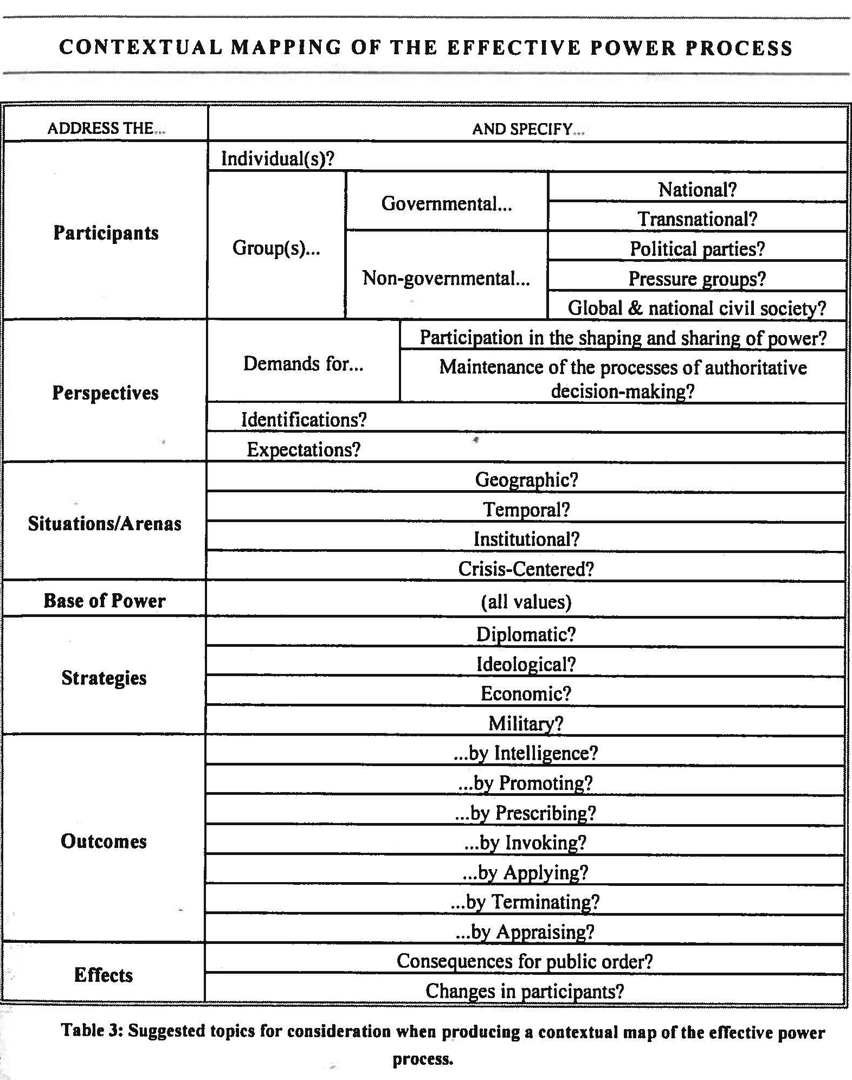

VII. From the Process of Effective Power to the Process of Constitutive Authority

- In the Western tradition, there is a great tendency to radically insulate the idea of law from the idea of political power. The general concern is that political power is exercised by an unprincipled and non-rule governed animus and therefore to contaminate law with power would deprive law of its authoritative component. This view was accelerated in importance during the period of the significant hegemony of Communist ideology. The Communist fear was that authority in law was simply a mask obscuring real power relations. Much of this kind of debate was unedifying. In reality, to maintain its efficacy law requires some measure of coercion and to retain its acceptance in community it requires some measure of authority. In short, law in the real world represents the confluence of authority and control, hopefully in balanced measures.

- What has been absent from the theoretical dialogue has been the effort to much more precisely map the relationship between effective power and controlling authority. Such mapping would require that we are able to specify with some detail the social process of effective power itself and to describe the social process of constitutive authority and to account for the precise points of convergence between authority and control.

- Mapping the Process of Constitutive Authority

- It is important to start with the participators in order to establish who operates from the perspective of naked power and who operates under the mantle of authority.

- Because authority may have wide references which include weak signals of authority, we will note that older forms of constitutional authority may seek to find authority in religion, the duly appointed agents of religion, kings and tyrants whose authority it is claimed comes directly from God, philosopher-kings whose authority comes from philosophy, oligarchies, aristocracies, or plutocracies.

- More contemporary discriminations about constitutional participators have gone beyond these traditional references to authority to involve the claim to direct democracy, participation by representation, universal suffrage, equality in participation, pseudo-democracy, in which participation is limited by race, class, caste, or gender, as well as special methods to enhance participation by non-self others. So we see even within the wide range of participators involved in the constitutive process that there still remains a great deal of contestation, the residue of naked power claims.

1. The Identities and Perspectives of the Participators

- There is a near-universal demand among participators that decisions be undertaken by criteria of authority rather than by naked power. In the contemporary world, strong demands are made that community members establish their own constitutional systems. Along with this demand is the notion that a constitution should control and regulate government itself so that governmental decision-making assures decisions in the common interest, including justice, freedom, and an improved living circumstance. The trend in modern constitution making has been explicitly influenced by global demand for universal human dignity and this emerges in the form of the deference given to fundamental rights deemed inalienable.

- Modern constitutional development has often been triggered by the role of conspicuous individuals who generate norms at the micro level, which gradually influences social activism and reshapes community expectations about fundamental rights. The examples of Gandhi, Rosa Parks, Nelson Mandela, Václav Havel, Emil Constantinescu, and Martin Luther King, Jr. are good illustrations of this phenomenon.

- More expectations from participators insist that the constitution direct government to promote positive social and economic ends for its citizens. Moreover, some expectations require constitutional prescriptions to be embraced with deep and overwhelming intensity such as jus cogens. Probably the most important expectation of constitutional authority is that law made that is not in conformity with constitutional expectations are regarded as laws made without authority.

2. Constitutional Situations

- In a diverse, contemporary cultural context, constitutional expectations experience the intermingling of religious and political institutional structures.

- Constitutional expectations invariably establish and separate distinct branches of government, forming different decision-making functions.

  - It is conventional wisdom that such structures will separate executive from parliamentary and from judicial functions. Constitutions establish or tolerate complex bureaucratic structures and generally provide for certain rules of natural justice to constrain an impulse to arbitrariness. Constitutions experiment with degrees of centralization and decentralization of basic governmental authority.

3. Bases of Power behind Constitutional Authority

- In general, constitutional authority either repudiates or remains uneasy about the idea that the sovereign is above the law. The most progressive principle from modern constitutional authority is that the constitution maintains the supremacy of the law over all social participants.

- Notwithstanding an objective, written constitution, interpreters still search endlessly for self-serving legitimacy myths. Such myths can include a mythical original contract or the idea that certain competencies permit some groups to control others. Still other myths dispute the reach of the franchise, the power of either the judiciary, the legislature, or the executive.

- Operational constitutions sometimes provide mechanisms to prevent decisions from being enacted by democratic means, which may serve as a base of power to those who occupy pivotal positions.

4. Strategies of Constitutional Authority

- Fundamentally, participators maintain an expectation that decisions within the body politic are undertaken by authorized, uniform, and observable procedures.

- There is also a great expectation that so far as possible the procedures of governance be transparent, responsible, non-coercive, and economic.

- Another implicit expectation is that the constitution itself must direct decisions to secure the social compact of the community.

- Because constitutions are not necessarily self-executing they have to be interpreted and this requires complicated skills for ascertaining, supplementing, and integrating fundamental constitutional expectations.

- Modern written constitutions explicitly formulate bills of rights with related competencies for clarification and enforcement, specify techniques of representation and parliamentary procedure, techniques of executive and bureaucratic action, and techniques of judicial review, as well as procedures to challenge decisions deemed to be incompatible with the authority of the constitution.

5. Outcomes of Constitutional Authority

- An important task of constitutional authority is to clarify different kinds of decision-making in the prescription and application of general communicative policies.

- Constitutional authority has to distinguish between the prescription of general policies and their application in instances of particularity. It must distinguish between the power of judging and the execution of the law itself. It must clarify those types of decisions that are quintessentially judicial, legislative, or executive.

- The constitutional process has to recognize that structures of government perform multiple functions and that any particular function of governance may be discharged by multiple governmental structures. Interpretation of the constitution has to shape such decisions and constrain them as reason permits.

6. Effects of Constitutional Authority

- Constitutional authority provides a continuous process of communication and collaboration to facilitate the just workings of the juridical system.

- It provides a mechanism by which conflict may be resolved by avoiding the destruction generated violent conflict.

- It provides a possibility of enlightened discourse and the progressive enhancement of social justice.
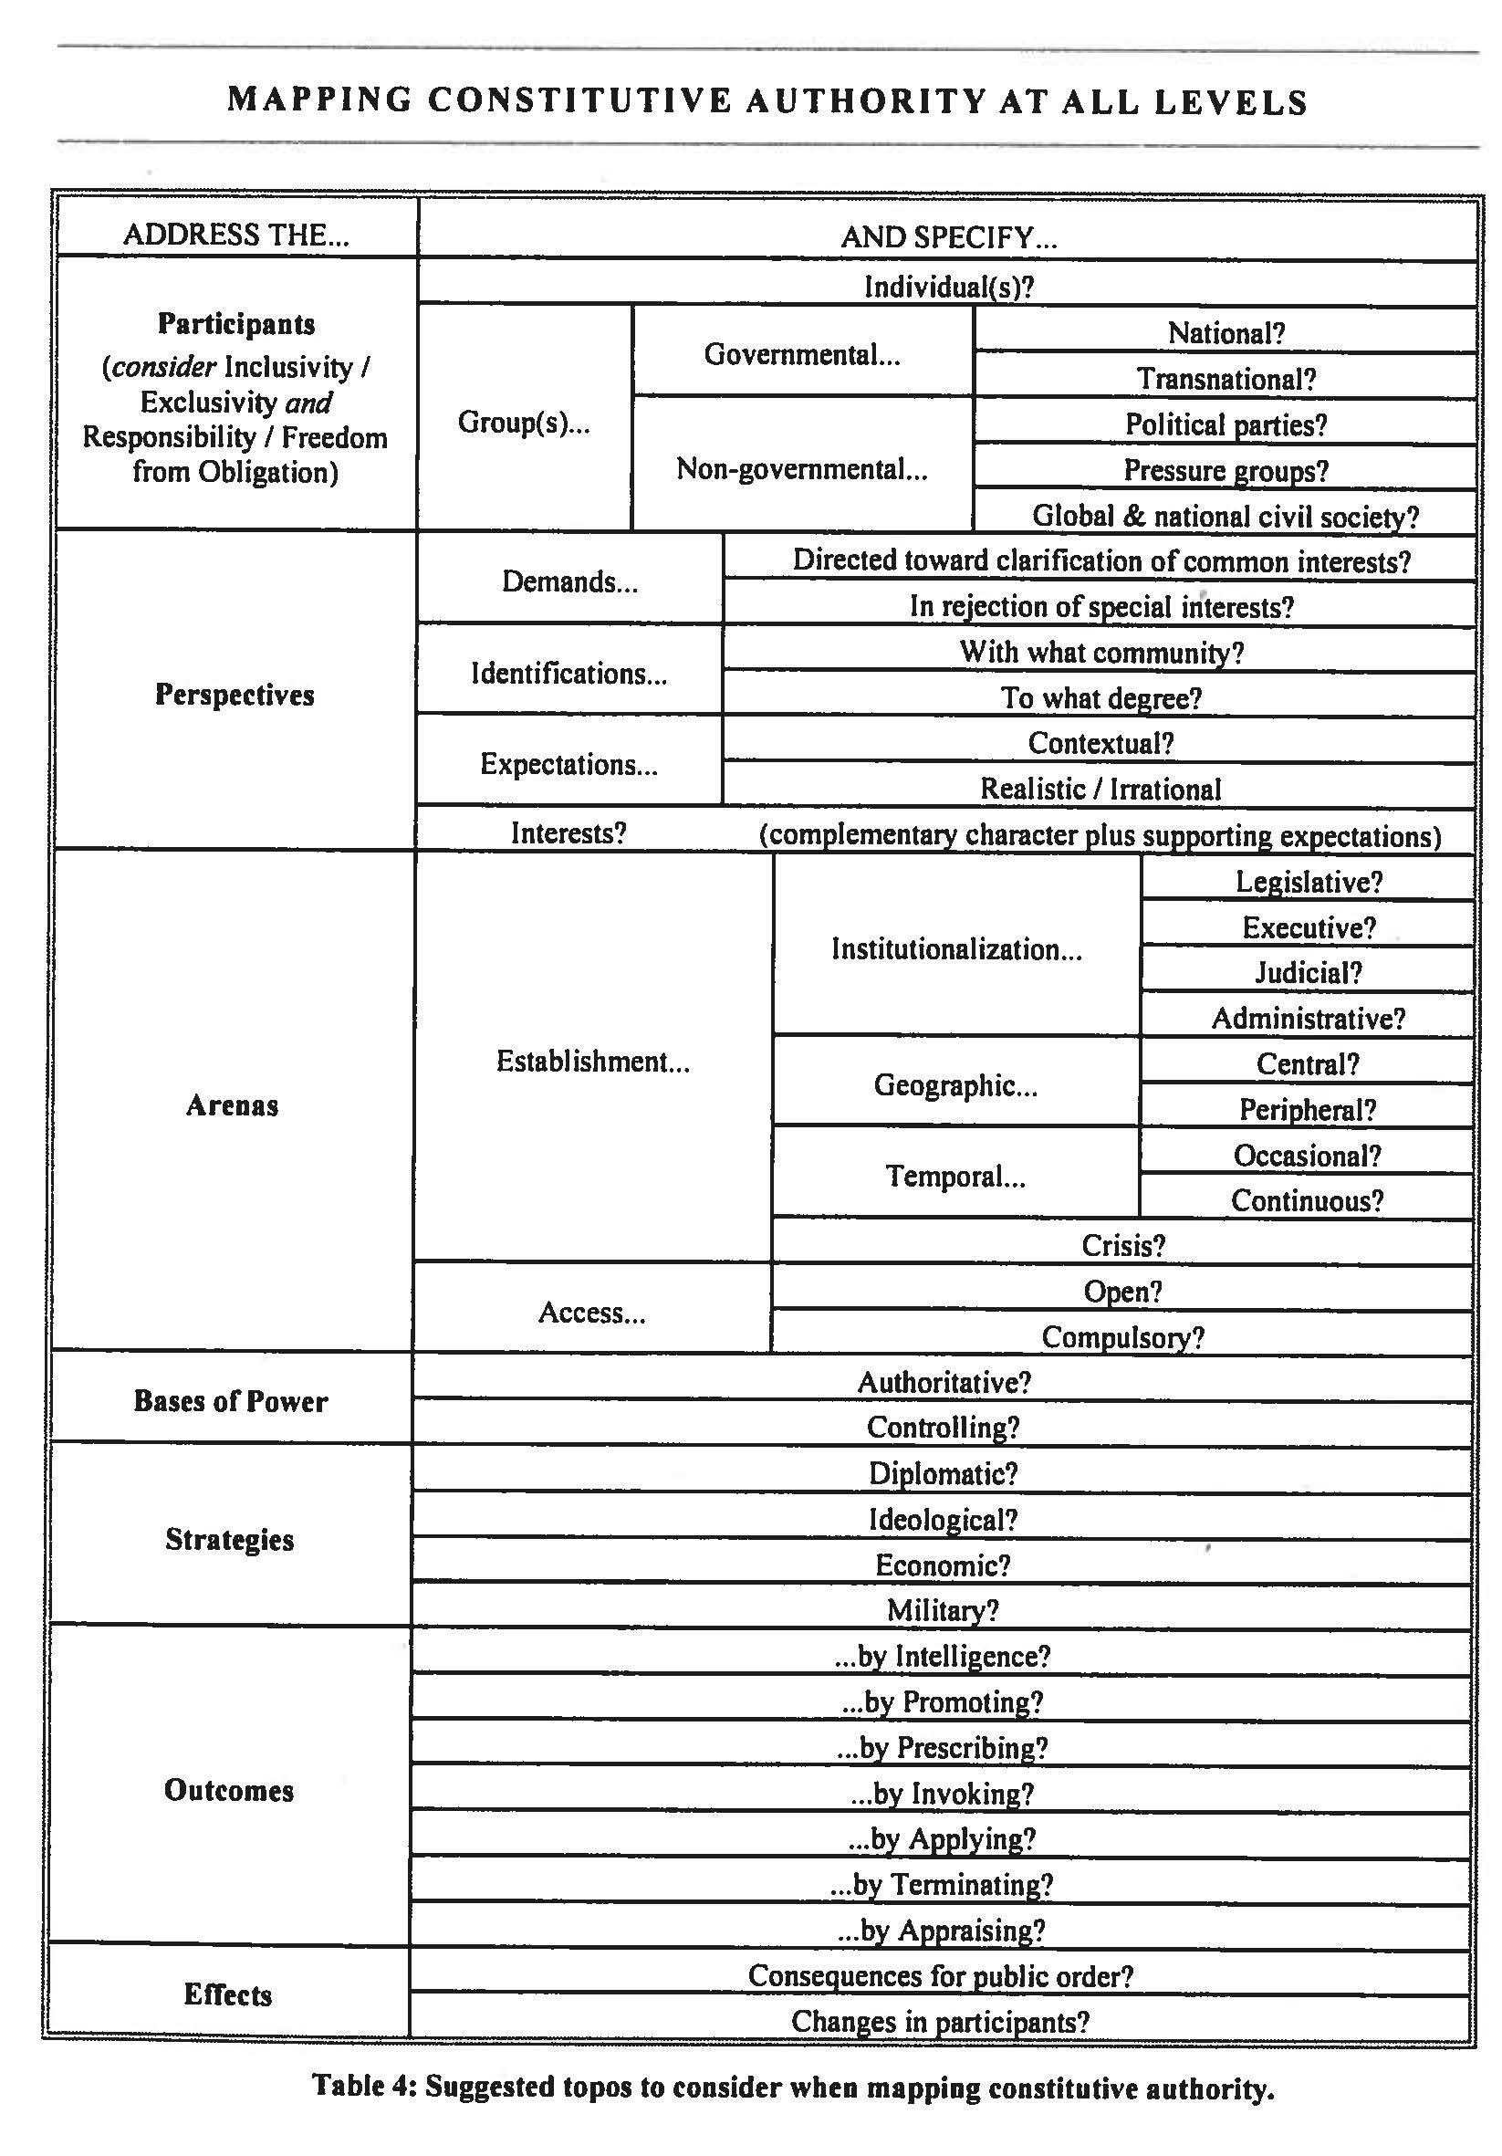

Footnotes: Malinowski, Crime and Custom in a Savage Society
Nagan, Contextual-Configurative Jurisprudence: The Law, Science and Policies of Human Dignity (Vandeplas Publishing: 2013), 91.
ibid., 93.
ibid., ___.

