HETERODOX ECONOMICS: SOME UNFINISHED BUSINESS
Annotated Outline
Jorge Thompson Araujo Joanílio Rodolpho Teixeira
The World Bank University of Brasília

ABSTRACT
Four or five decades ago, heterodox luminaries such as Richard F. Kahn, Nicholas Kaldor, Joan Robinson, Luigi Pasinetti, as well as Paul Davidson stood shoulder to shoulder with their mainstream counterparts and published in the major mainstream journals. The situation today is very different. Heterodox economics progressively developed as a separate branch (with many sub-branches). Heterodox economists are no longer welcome to publish in the most prestigious journals and hold their separate conferences and seminars. There is very little communication between mainstream and non-mainstream branches of economics. This schism is the result of failings on both sides. The aim of this paper is to start outlining an agenda for heterodox economics to help overcome its complete disconnect from the mainstream. While this cuts both ways, this paper will focus mainly on the heterodox side. The paper concludes that heterodox economists deserve to be heard by the mainstream – for the latter’s own good.

Key words: Heterodoxy, mainstream, orthodoxy.
JEL classification: P16, B00, B50
I. Introduction
- Four or five decades ago, the pupils of J. M. Keynes and founders of heterodox economics mainly teaching in Cambridge U.K., – Richard F. Kahn, Nicholas Kaldor, Joan Robinson, Luigi Pasinetti, as well as Paul Davidson (the latter working in the USA) – stood shoulder to shoulder with their mainstream, mainly U.S., counterparts and published in the major mainstream journals, such as QJE, RES, and Econometrica. In the beginning, they were not even labeled as “heterodox” as such; and they had ample space in most economics literature.
- The situation today is very different. Heterodox economics progressively developed as a separate branch (with many sub-branches). Heterodox economists are no longer welcome to publish in the most prestigious journals and hold their separate conferences and seminars. There is very little communication between mainstream and non-mainstream branches of economics. This schism is the result of failings on both sides.
- The aim of this paper is to start outlining an agenda for heterodox economics to help overcome its complete disconnect from the mainstream. This cuts both ways – but this paper will focus on the heterodox side.
II. A “Family Tree” of Heterodox Economics
- Any attempt to outline the main intellectual foundations and perspectives of heterodox economics runs the risk of leading to gross oversimplification.
- However, it is possible to identify a “family tree” of heterodox economics, going back all the way to classical economists such as Adam Smith, David Ricardo and Karl Marx, as well as to later contributions by J.M. Keynes.
- There are many economists who could be placed on multiple branches of the family tree. Some of the arrows in the diagram below show influences – although it is not entirely clear whether these are indeed influences or explicitly acknowledged as such by the influence – or interdependencies. A clear example of influence is the one observed between Kalecki and the neo-Kaleckians.
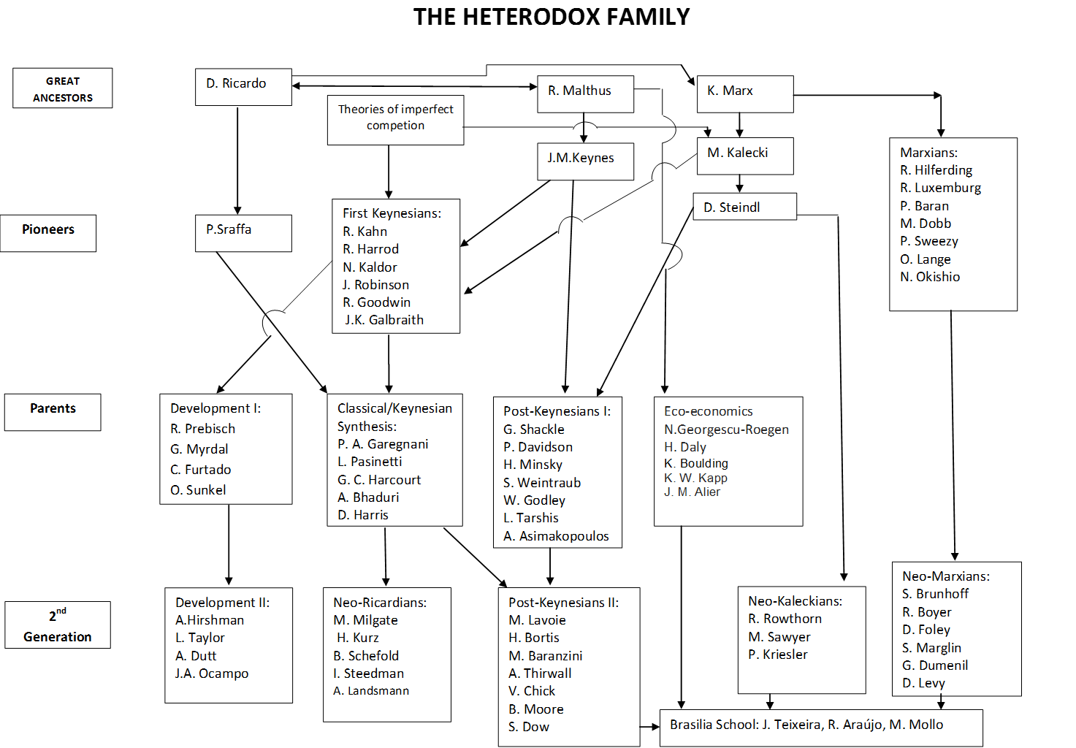

III. Unorthodox Results from Mainstream Economics
- This section will do two things: (i) distinguishing between “mainstream” and “orthodoxy”, in line with Colander, Holt and Rosser Jr. (2004); and (ii) provide examples of unorthodox results from mainstream economics.
- Mainstream vs. Orthodoxy:
  - “Mainstream consists of the ideas that are held by those individuals who are dominant in the leading academic institutions, organizations, and journals at any given time, especially the leading graduate research institutions. Mainstream economics consists of the ideas that the elite in the profession finds acceptable, where by ‘elite’ we mean the leading economists in the top graduate schools.” (Colander et al, p. 490).
  - “Orthodoxy generally refers to what historians of economic thought have classified as the most dominant ‘school of thought’, which today is ‘neoclassical economics’. In our view, modern mainstream economics is quite different from this neoclassical concept of orthodox economics”.
  - Heterodox economists often confused “mainstream” with “orthodoxy”. [Note: James Kwak’s concept of “economism” is useful in this regard].
- Unorthodox results from mainstream economics: Lots of possible examples, such as the works of Piketty, Rodrik, Stiglitz, Farmer, De Long, Krugman, Tony Atkinson and other “progressive” mainstream economists.
- The mainstream is guilty of one basic sin: The acceptance of just one type of methodological approach (methodological individualism):
  - Rodrik (2015, pp. 199-200): “So economics offers limited room for methodological pluralism – much less than it allows for diversity in policy conclusions”.
IV. The Weak Points of Heterodox Economics
- Modeling and discourse are often not aligned: while much of heterodox discourse emphasizes money, uncertainty and historical time, most heterodox models are moneyless, equilibrium-based, and with little discussion of uncertainty and expectations.This apart from a number of exceptions.
- Heterodox models might be subject to the Lucas critique, and an appropriate response must be crafted.
- Heterodox economics has focused a lot on theory and much less so on empirics: As Solow (1996, p. 251) noted, “The Kaldor-Kalecki-Robinson-Pasinetti line made life harder for itself by being part of a wholesale attack on mainstream economics. Anyway, it was never able to muster a body of serious applied work.” The same is maintained in a letter by Paul A. Samuelson (see Baranzini and Mirante, 2016).
- Heterodox economics finds it struggling to have a just space in most modern textbooks. There was a time (in the 1960s and 1970s) where J. Robinson and J. Eatwell, Luigi L. Pasinetti, and few others published with some success their textbooks; but in the recent years this seems to have slowed down.

V. What Heterodox Economics Has to Offer to the Mainstream
- The weaknesses discussed in the previous section does not invalidate the many good things that heterodox economics has to offer, such as:
  - Macro-financial stability: Minsky and others.
  - Macroeconomic analysis more generally: Godley-Lavoie and others.
  - Growth and development: Kaldor’s growth laws; the work on development economics by Taylor, Thirlwall, Dutt and others.
  - Structural change: Pasinetti and associates [Note: Structural change is now a thriving field in the mainstream, and heterodox contributions are virtually ignored].
  - Functional distribution of income: Cambridge school; Dumenil and Levy [Note: Piketty’s work helped resurrect mainstream’s interest in factor income shares]
VI. Conclusions and the Way Forward
- “Orthodox” economic theory can generate “heterodox” policy implications:
  - Government intervention justified by orthodox analyses of market failures, externalities, informational asymmetries, and increasing returns to scale.
  - Involuntary unemployment in New Keynesian models is possible in the short run, requiring countercyclical fiscal or monetary policies.
- Existing heterodox economic theories have a lot to contribute to a renewal of economic thinking:
- “Mainstreaming” or “normalizing” heterodox economics? Heterodox economists deserve to be heard – for the mainstream’s own good.

Selected Bibliography:

Baranzini, M. and A. Mirante (2016). A Compendium of Italian Economists at Oxbridge: Contribution to the Evolution of Economic Thinking. Palgrave MacMillan.

Colander, D.; R. Holt, and B. Rosser Jr. (2004). “The Changing Face of Mainstream Economics”. Review of Political Economy, 16: 4, 485-499.

Dow, S. and J. Hillard (2002). Post Keynesian Econometrics, Microeconomics and the Theory of the Firm. Edward Elgar.

Dutt, A.K. (2015). “Uncertainty, Power, Institutions, and Crisis: Implications for Economic Analysis and the Future of Capitalism”. Review of Keynesian Economics, Vol. 3, No. 1, 9-28.

Farmer, Roger (2016). “Post Keynesian Dynamic Stochastic General Equilibrium Theory”. Manuscript, UCLA.

Hoover, K. (2013). “Review of J.E. King’s ‘The Microfoundations Delusion: Metaphor and Dogma in the History of Macroeconomics’. Center for the History of Political Economy, Duke University, CHOPE Working Paper No. 2013-13.

King, J.E. (2012). The Microfoundations Delusion: Metaphor and Dogma in the History of Macroeconomics. Edward Elgar.

Kwak, J. (2017). Economism: Bad Economics and the Rise of Inequality. Penguin Random House.

Pasinetti, L. (1981). Structural Change and Economic Growth: A Theoretical Essay on the Dynamics of the Wealth of Nations. Cambridge University Press.

Piketty, T. (2013). Capital in the Twenty-First Century. Belknap Press.

Rodrik, D. (2015). Economics Rules: The Rights and the Wrongs of the Dismal Science. W.W. Norton.

Skott, P. (2009). “Theoretical and Empirical Shortcomings of the Kaleckian Investment Function”. University of Massachusetts Amherst, Department of Economics Working Paper.

Skott, P. (2012). “Pluralism, the Lucas Critique, and the Integration of Macro and Micro”. University of Massachusetts Amherst, Department of Economics Working Paper.

The findings, interpretations and conclusions expressed herein are those of the authors and do not necessarily reflect the view of the World Bank Group, its Board of Directors or the governments they represent. Email addresses: jaraujo@worldbank.org (for Jorge Thompson Araujo) and joanilioteixeira@hotmail.com (for Joanilio Teixeira).
It is worth noting the influence of the Polish economist Michal Kalecki to the richness and complexity of this economic literature. However, some argue that his contributions have remained somewhat stifled for a long time due to his unorthodox approach.

