World Academy of Art & Science
Strategic Positioning & Program Framework

I. Strategic Positioning of WAAS 1
1. Context for this Strategic Plan 1
2. WAAS Vision 3
3. WAAS Mission 4
4. WAAS Capabilities & Resources 5
5. Essential Conditions to Fulfill WAAS Mission 5
6. Strategic Goals 2010-2015 5
II. Program Strategy 6
1. Characteristics of Reliable Knowing 7
2. Perspectives on the Emerging Global Context 9
3. Program Framework 11
4. Program Thrust Areas 12
III. Real Ideas to Change the World 13
1. Issues-based Approach 13
2. Real Ideas Framework 13
3. Full and Guaranteed Employment 14
4. Global Governance 15
5. World University – example of a world-changing idea 15

Strategic Positioning of WAAS

Context for this Strategic Plan
This year marks the fiftieth anniversary since the establishment of the World Academy. By 1960 a decade of very rapid economic growth in OECD countries had strongly reinforced faith in the positive powers of modern science and technology. Yet at the same time, memories of the devastating impact of modern military technology during two world wars were still fresh in the minds of our founders. Cold War tensions were at their height and the proliferation of nuclear weapons was accelerating. International scientific collaboration and intellectual exchange were severely constrained by the Iron Curtain and limitations in international transport and communication. The population explosion had begun, but awareness of environmental threats was in its infancy and had not yet become a subject of serious research. Multidisciplinary studies were yet to gain respectability. Intellectual exchange between the arts, sciences and humanities was rare. In this environment the Academy’s founders saw a pressing need and a precious opportunity to expand peaceful, transnational interchange of ideas among intellectuals of all fields to arrest the dangerous momentum arising from the application of science and technology for destructive purposes and to address the unmet social needs and rising aspirations of the rapidly awakening nascent global society.
The situation today is in many ways very different, but in some ways remarkably similar to what it was at the Academy’s inception. The threat of large scale hot and cold war has receded, but the proliferation of nuclear and other destructive weaponry is an ever-present threat. A doubling of global population combined with a tripling of average per capita GDP has generated serious environmental stresses that were unforeseen 50 years ago. After the end of the Cold War, the process of globalization has accelerated dramatically, carrying the instruments of science and aspirations for prosperity to people around the globe. Radical improvements in global communications, especially since the advent of the Internet, have created opportunities for rapid, inexpensive global interactions that were inconceivable earlier. Although multi-disciplinary studies have been prevalent for decades, academic research related to the social sciences is still highly specialized and fragmented. Yet at the same time, it is becoming increasingly apparent that the pressing problems challenging humanity such as national security, climate change and international financial management require a comprehensive and inclusive approach that takes into account the widest range of social factors and policy instruments.
From its inception, the Academy has demonstrated a remarkable capacity to explore new perspectives on important issues, such as population studies, environmental challenges and the emergence of the information society, long before they became prevalent. Looking back at its activities over the past five decades, it is evident that the founders of the Academy had a vision that was well ahead of its time, but that the circumstances and means were not yet fully conducive for its implementation. This is no longer true. Today both the necessity and the possibility of original, trans-disciplinary, transnational collaboration between the arts, humanities and sciences are fully apparent. The necessity arises from the complexity of the challenges we face. The possibility arises because the development of competent academic institutions in all parts of the world combined global communications technologies.
In recent years the management of the Academy has committed itself to reviving the original spirit and vision of service which led to the founding of this institution. Steps are underway to broaden our membership both geographically and discipline-wise, to alter our management structure and methods to promote greater involvement of members and greater transparency, to strengthen and focus programming on emerging trans-disciplinary issues, to evolve a more comprehensive approach inclusive of differing perspectives, and to effectively leverage the power of the latest communication technologies to increase the frequency and reach of our activities.
Fifty years after its founding, WAAS remains the only truly global, intellectually inclusive, trans-national academy in the world, an organization of socially and ethically committed individuals, possessing outstanding intellectual expertise covering a wide range of fields, with linkages and networking capabilities to outstanding individuals and organizations worldwide. The views expressed during the planning process reveal a consensus of our Fellows that there are serious unmet needs which the Academy has the potential to meet. One of the challenges is to fully leverage our unique capabilities by means of emerging technologies for collaborative partnership with other local, regional and international organizations.
Yet it is also clear that the in an age of global networking, the unique composition of our membership is not sufficient basis for the Academy’s existence. In order to fulfill the original intention of the Academy’s founders and justify the organization’s continued existence, WAAS must be able to demonstrate a creative capacity to contribute meaningfully to addressing the issues facing humanity in a manner that adds to or complements that of other organizations. Our existence can only be justified by our actions and as an intellectual organization those actions must include the generation and projection of original insights, ideas, perspectives or solutions to the opportunities and challenges of the 21st century.
At the same time, we need to acknowledge our limitations – the low level of involvement and interaction among our members, the low level of public awareness and visibility, inadequate financial resources, and almost complete dependence on voluntary efforts of career professionals, rather than on dedicated staff to carry out its work. These are challenges that certainly can be overcome by a leadership inspired by the Academy’s founding ideals and by being fully dedicated to realizing them in practice.
The formulation of this strategic plan describes a way to revitalize and reposition the Academy so that it can make the unique and original contribution envisioned by our founders, which is now so urgently needed to address humanity’s pressing problems and emerging opportunities.

WAAS Vision
The world is in need of guiding ideas, a vision, to more effectively direct our intellectual, moral and scientific capabilities for world peace, global security, human dignity and social justice. Today we face myriad challenges. Unprecedented material and technological achievements co-exist with unconscionable and in some cases increasing poverty, inequality and injustice. Advances in science have unleashed remarkable powers, yet these very powers as presently wielded threaten to undermine the very future of our planet. Rapidly rising expectations have increased frustrations and tensions that threaten the fabric of global society. Prosperity itself has become a source of instability and destruction when wantonly pursued without organizational safeguards for our collective well-being. No longer able to afford the luxury of competition and strife based primarily on national, ethnic or religious interests and prejudices, we need urgently to acquire the knowledge and fashion the institutions required for free, fair and effective global governance.
Humanity’s progress has been driven by democracy, technology, education, social organization, knowledge, cultural and spiritual values. War, exploration, the quest for empire, trade, money, agriculture, urbanization, industrialization, science and religion have each in turn played a role. Yet the accumulated knowledge and mastery of the material world and biological processes provide insufficient guidance to meet our present challenges. We need also to acquire a commensurate knowledge of ourselves as an evolving race, the sources of our creativity and our errors, the processes that govern our individual and collective advancement, as well as the inherent tendencies of our race that oppose and often destroy our most cherished values and accomplishments.
In recent centuries the world has been propelled by the battle cry of revolutionary ideas – freedom, equality, fraternity, universal education, workers of the world unite. Past revolutions have always brought vast upheaval and destruction in their wake, tumultuous and violent change that has torn societies asunder and precipitated devastating wars. Today the world needs evolutionary ideas that can spur our collective progress without the wake of destructive violence that threatens to undermine the huge but fragile political, social, financial and ecological infrastructures on which we depend and strive to build a better world.
Until recently, history has recorded the acts of creative individual thinkers and dynamic leaders who altered the path of human progress and left a lasting mark on society. Over the past half century, the role of pioneering individuals is increasingly being replaced by that of new and progressive organizations, including the international organizations of the UN system and NGOs such as the Club of Rome, Pugwash and the International Physicians for the Prevention of Nuclear War. These organizations stand out because they are inspired by high values and committed to the achievement of practical, but far-reaching goals. This was, no doubt, the intention of the Academy’s founders when it established this institution in 1960 as a transnational association to explore the major concerns of humanity in a non-governmental context. The WAAS manifesto is contained in Annexure D.
The founders of WAAS were motivated by a deep emotional commitment and sense of responsibility to work for the betterment of all humankind. Their overriding conviction was on the need for a united global effort to control the forces of science and technology and govern the peaceful evolution of human society. Inhibiting conditions limited their ability to translate these powerful motives into action, but they still retain their original power for realization. Today circumstances are more conducive, the international environment is more developed. No single organization can by itself harness the motive force needed to change the world, but an organization founded with such powerful intentions can become a magnet and focal point for like-minded agencies to project creative ideas that possess the inherent dynamism for self-fulfillment.

WAAS Mission
The World Academy of Art and Science is an association of committed individuals drawn from diverse cultures, nationalities, occupations and intellectual pursuits spanning the arts, humanities and sciences, conscious of the profound social consequences and policy implications of knowledge, and united by a common aspiration to address the urgent challenges and emerging opportunities confronting humanity today. Our mission is to promote cross-disciplinary dialogue generative of original ideas and integrated perspectives that comprehend the root causes and effective remedies for our common problems, while furthering those currents of thought and social movement that affirm the value of human dignity and equitable development. The Academy dedicates itself to the pursuit of creative, catalytic ideas that can provide to present and future generations enlightened leadership in thought that leads to effective action.

WAAS Capabilities & Resources

The only academy that is truly global and intellectually all-inclusive

Socially and ethically committed members

Outstanding intellectual resources

Expertise covering a wide range of fields

Social status of the Academy providing access to individuals & organizations

Networking capabilities of our Fellows

Advanced communication technologies

Potential partnerships with local, regional & international organizations

Essential Conditions to Fulfill WAAS Mission
In reflecting upon the WAAS Mission, it is evident that translating the intentions of the Board into actual achievements will be a challenging and demanding task. The five conditions listed below are essential requirements, and also should be sufficient, for WAAS to make the real impact set forth in the Mission.

Inspired visionary leadership and dynamic effective organization.

Original ideas, integral perspectives and comprehensive solutions to crucial issues facing humanity today.

Active membership committed to working in and through the Academy.

Partnerships with like-minded, complementary institutions to maximize the network effect.

The ability to attract financial resources commensurate with its objectives.

Strategic Goals 2010-2015

Target to build a core of at least 400 committed Fellows who are actively engaged in the programs of the Academy.

Develop an on-going stream of programming based on the criteria set forth in the strategic plan.

Become widely recognized in the world as a preferred global platform where thinkers and organizations from all regions can collaborate effectively to create and offer meaningful innovative responses to the greatest challenges facing humankind.

Make significant positive differences, have lasting impacts, and attract participants of global caliber and potential in every arena of our focus.

Activate existing divisions and develop new regional divisions of the Academy in order to enhance local relevance and application of the Academy’s programs, increase participation of fellows and enhance fund raising capabilities.

Program Strategy & Objectives
At the time the Academy was founded, there were very few international non-governmental organizations devoted to the free exchange of ideas and none so encompassing in its breadth as WAAS. The very conception of the Academy constituted an original idea and a pioneering initiative. In the present age of globalization, networking and the World Wide Web, this is no longer true. The unique composition of our membership is no longer sufficient justification for the Academy’s existence. During the early phase of the strategic planning process, WAAS Fellows were unanimous in describing and conceiving of this as a value-driven organization that makes a significant and concrete contribution to addressing the pressing problems of the world today. A broad umbrella for diverse interdisciplinary dialogues may form one part of the Academy’s program, but our unique composition needs to be leveraged to generate original and unique perspectives that transcend current knowledge and contribute meaningfully to addressing real social issues. Generating and projecting original insights, ideas, perspectives or solutions to the opportunities and challenges of the 21st century is a tall order, but it is the only meaningful way for us to activate our membership and play the significant role in world affairs envisioned by our founders.
With these objectives in mind, the SPC sought to develop a Program Framework that would be sufficiently focused to address the most pressing contemporary social issues while at the same time sufficiently broad to encompass the full spectrum of the arts, humanities and science. It became evident that in order to generate original and unique ideas, the framework would need to start by recognizing the limitations in current approaches to knowledge and formulating its own conception of the type of knowledge the world needs. After concluding that traditional planning models did not fully suit the aims of the Academy, the Committee applied the Foresight Onion model mentioned in the introduction and described in detail in Annexure B.
The Foresight model starts by examining our conception of reliable knowledge and proceeds from there to identify a set of perspectives that can be applied to evolve original insights and ideas relating to a wide range of issues. The steps in this process are described in the following sections of this report:
II.1. identifies seven criteria for reliable knowing consistent with the founding conception of the Academy.
II.2. derives six perspectives based on these criteria, which can be applied to arrive at reliable knowledge pertaining to global challenges and opportunities. These perspectives are intended to serve as conceptual guidelines for the definition and resolution of issues.
II.3 presents a simple conceptual model of the program framework.
II.4 further defines specific program thrust areas.

Characteristics of Reliable Knowing
The reliability of our knowledge determines our ability to properly understand problems and formulate effective solutions. Therefore, it is essential that the Academy’s strategic plan and program framework incorporate criteria for reliable knowing. This section identifies fundamental characteristics of reliable knowing which can be applied to the identification, comprehension, and effective response to social and policy issues. 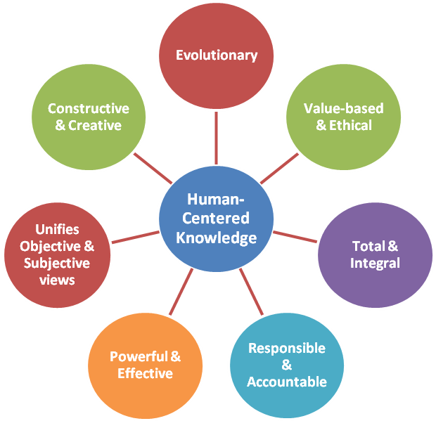
Figure 1: Characteristics of Reliable Knowing
Human-centered Knowledge: Reliable knowing related to social consequences and policy implications must place pre-eminent value on the welfare and well-being of human beings, individually and collectively, and the sustainable development of human society.

Evolutionary Perspective: Reliable knowing should recognize that human institutions exist in an ever-changing, ever-evolving social context, so that yesterday’s knowledge may no longer reflect the values, ideals and social realities of today or tomorrow.

Value-based or Ethical Perspective: Knowledge of human systems must be judged by the values it seeks to fulfill, for the laws and processes governing society and human behavior are created by human beings for human welfare.

Total & Integral: Reliable knowing is interrelated and inseparable based on an integral knowledge of society and humanity that transcends and unifies partial perspectives. It encompasses and integrates the perspectives of the sciences, arts, and humanities.

Responsibility & Accountability: Reliable knowing with respect to human systems is based on an explicit or implicit understanding that human beings are fully empowered, responsible and capable of resolving the problems they create.

Reunites the Objective & Subjective: In the study of humanity and society, there is no objective truth independent of the subjective perceptions and attitudes of those who examine it. Reliable knowledge identifies the subjective points at which our attitudes and behavior must change to effectively address a problem that manifests objectively in the world around us.

Constructive & Creative: Reliable knowledge is based on the creative imagination to perceive the opportunities as well as the challenges, the solutions as well as the problems.

Powerful & Effective: Reliable knowledge contains within itself effective power for action. Reliable knowledge is complete knowledge which addresses problems without giving rise to new problems or generating unintended negative side effects.

Perspectives on the Emerging Global Context
In this section, the principles of reliable knowing are applied to formulate a set of perspectives for approaching global issues. Based on the criteria for reliable knowing, it identifies seven perspectives which can be applied to arrive at reliable knowledge pertaining to global challenges and opportunities. These perspectives are intended to serve as conceptual guidelines for the definition and resolution of issues. These perspectives are illustrated in Annexure E with a few representative examples addressing a wide range of issues.

Human Welfare & Well-being: A human-centered, value-based perspective on the human context is one which is centered on meeting the needs of all human beings in the most equitable and effective manner. Each aspect of the global context should be evaluated in terms of how effectively it meets fundamental human needs and the highest human values.
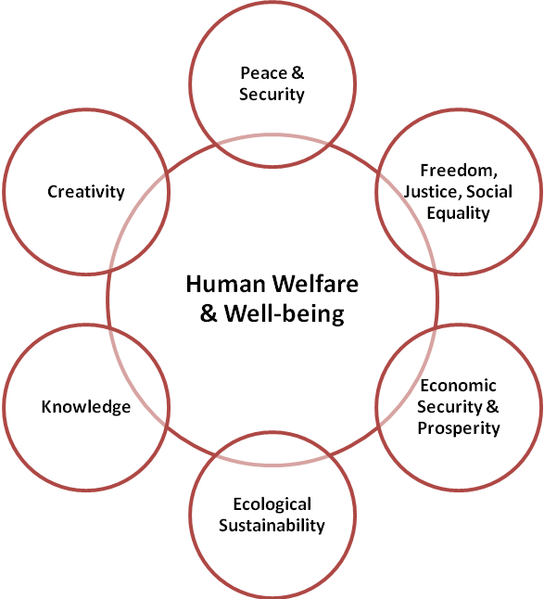
Figure 2: Human-centered Knowledge
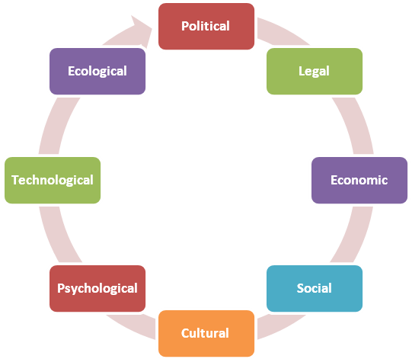
Figure 3: Comprehensive Perspective & Solutions

Whole World Perspective: All people, nations, and fields of activity constitute a single integral whole that is in a process of continuous evolution and whose parts are continuously interacting with one another to create new opportunities and challenges.

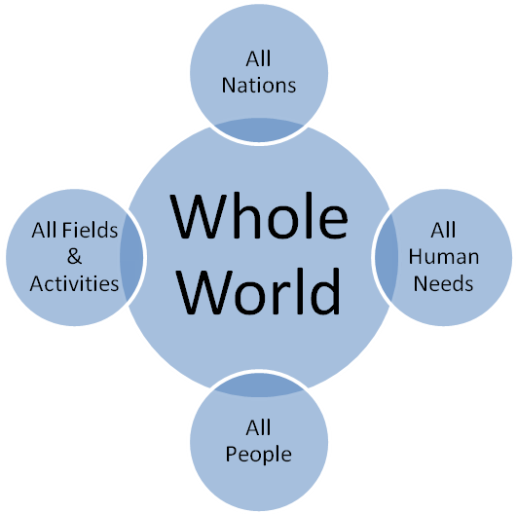
Figure 4: Whole World Perspective

Evolutionary Perspective: Reliable knowledge has to view past, present and future as various points on an ever evolving continuum. Past theory and precedent is an insufficient qualification for future practice.

Opportunity-based Perspective: Reliable knowing should lead to the creation and identification of new opportunities, not merely a preoccupation with solving problems and meeting anticipated challenges.

Effective Knowledge: In the measure knowledge is reliable, it generates real power to solve problems and tap opportunities without unexpected and undesirable consequences associated with partial knowledge. Knowledge is effective when it is comprehensive and when it takes into account both the objective and subjective dimensions.

Program Framework
The primary objective of the Academy’s founders was to promote human welfare through the application of knowledge that is global, objective, scientific and imbued with the highest ethical standards and sense of responsibility. The Manifesto they drafted in the name of Science and the Future of Mankind identifies the enemies of peace that need to be conquered as hunger, sickness, waste and destruction, intolerance, ignorance, resignation and fear.
As we enter the 21st century, it is evident that the problems of security, economy and ecology facing humanity now cannot be effectively addressed at the national level. Global governance and sustainable development, broadly defined, encompass the major fields through which the application of reliable knowledge is needed to promote human welfare.

Global governance includes issues such as the elimination of war, abolition of nuclear and other weapons of mass destruction, global financial management, ecological security rule of law, democratization at the national and international level, etc.

Sustainable development includes issues related to life styles and living standards, employment, health, education, and culture. In fact, most issues of global significance today span both categories to some extent. For example, employment security and financial stability can no longer be adequately addressed without international cooperation.
The Program Framework is an inclusive approach intended to provide focus and perspective, not to limit or exclude any important issue or field of knowledge. The approach is issue-based rather than based on the traditional division of disciplines. It is a means of conceptualizing issues of global significance in a manner that ensures a human-centered perspective and recognizes the central importance of a applying a comprehensive integral knowledge. The program framework is depicted in Figure 5 below.

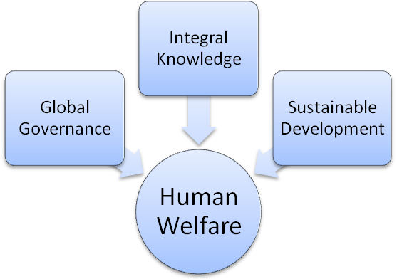
Figure 5: Program Framework

Program Thrust Areas

The broad conceptualization presented in the Program Framework lends itself for application to a very wide range of issues. Based on ideas and proposals from fellows generated during the planning process, the Program Framework can be further defined in terms of major thrust areas. The delineation of thrust areas is intended to create a focused agenda, but it is sufficiently inclusive to encompass a very wide range of issues such as global security, global financial management, economics of human welfare, democratic global governance, human security, education, science, research, sustainable development, national sovereignty, global development, environmental degradation, global interconnectedness, the internet, freedom, rising expectations, money, law and governance, health and health care, as well as 13 other evolutionary trends as discussed in Annexure E.

Major thrust areas:
Reliable Knowledge to promote Human Security, Welfare & Well-being
Governance
- Effective Democracy
- Global Security
- Ecological Resilience
Development
- Educational Advancement
- Equitable Prosperity
- Cultural Enrichment

Arts & Humanities: Special reference is necessary with regard to the arts and humanities. Although both are encompassed under the educational and cultural thrust areas, some may consider that they deserve separate consideration. Reflecting on the intentions of the Academy’s founders, we conclude that their primary purpose was to address pressing social issues. Their rationale for bringing together the Arts & Sciences was to demonstrate the relevance of all intellectual viewpoints to forge an integral perspective on these issues, rather than to promote any particular field of knowledge. Therefore, the program framework and thrust areas are focused on issues rather than subjects.

Real Ideas to Change the World

Issues-based Approach
The Program Framework provides guidelines regarding the type of knowledge and the types of issues that the Academy should seek to address. It does not identify any specific issues on which WAAS can make a significant original contribution to global human development.
The identification of a specific message to project – one or more positions the organization stands for -- has been one of the factors distinguishing organizations such as Club of Rome and Pugwash, whose programs have had visible, global impact.
The decision of the Board in 2007 to adopt the Abolition of Nuclear Weapons as a specific objective of the Academy marked a significant step in identifying WAAS as an organization that stands for an idealistic position on an issue of paramount concern to our founders. This decision did activate the participation of some Fellows, generated a series of events, and a collaboration with GSI, Middle Powers Initiative and Jasjit Singh’s India disarmament movement. The limitation we have faced on this issue, has been our inability to define a unique position or contribution that we could make to distinguish the Academy from Pugwash, IPPNW, Global Security Institute and countless other organizations dedicated to a similar goal.

Real Ideas Framework
As a complement to the Program Framework described above, the SPC recommends that the Academy also adopt an approach designed to identify specific issues on which WAAS can make a significant, original contribution.
Real Ideas can be defined as ideas with self-effectuating power. The acceptance of the idea carries with it the capacity to change our perceptions, attitudes and actions.
From Problems to Solutions: The program framework identifies global issues of importance. The emphasis is on a problem that needs to be recognized and addressed. Here the focus is on advocacy of original ideas, bold strategies and essential actions that are needed to resolve challenges and tap opportunities. We do not just discuss an issue. We take a position on what should be done to address it.
Over the next two years, the Academy should seek to identify 3-5 Real-Ideas that can change the world, ideas akin in their originality, scope and broad appeal to the Club of Rome’s conception of “limits to growth.” Whatever controversy may be associated with the idea, the fact remains that it raised the issue of sustainability to the top of the world’s intellectual agenda and has prompted constructive research and discussion of this crucial issue throughout the world.
WAAS should ask the following question to its entire membership: “Identify three to five original ideas that, if widely publicized, accepted and implemented today, can have the most profound positive impact on the future welfare and well-being of humanity.”
The very act of asking this question will help energize and generate greater involvement among our fellows and communicate to them the Academy’s intention of making a real difference in world affairs.
Once identified, the Academy can utilize its vast network of relationships with leading thinkers and organizations to project these seminal ideas and partner with other organizations to create an umbrella agency to bring these ideas into public awareness and promote their actual implementation.
Strategic Partnerships have a crucial role to play in this strategy. Once the Academy has identified, developed and endorsed a powerful idea for dissemination, it can act as an umbrella or magnet for other organizations with similar or complementary views, so that the idea acquires the characteristics of a social movement.
Some issues that could lead to the formulation of Real Ideas are discussed below to illustrate the approach.

Full and Guaranteed Employment
Full and guaranteed employment is global in significance and essential for achieving equitable and sustainable human security, yet even ILO has not had the courage to take a clear position on this issue for political reasons. The proceedings of the Academy’s Global Employment Challenge include compelling arguments for the adoption of full and guaranteed employment as a fundamental human right and policy of every government. In view of the widespread concern today with high and rising levels of unemployment, effective advocacy of this view could propel this issue to greater international visibility. Through the GEC, WAAS is already associated with a number of organizations committed to this goal. The Academy can partner with organizations such as ILO, Asian Development Bank, Centre of Full Employment and Equity, University of Newcastle (Australia); the Cambridge Centre for Economic & Public Policy, University of Cambridge; Levy Economics Institute of Bard College (USA) and the Center for Full Employment and Price Stability (CFEPS), University of Missouri-Kansas City.
Integration of education with employment – The GEC has documented that a major reason for inadequate job growth is the widening gap between the skills required by modern economies and the actual prevalence of skills in the work force of both economically advanced and developing countries. This is one manifestation of the disconnect between the present system of education and the evolving needs of society. A restructuring of educational methods and content to align it with emerging social needs will dramatically speed job creation and reduce unemployment. WAAS could partner with organizations such as UNESCO, UNDP and UNIDO on this issue.
Employment and Social Stability – The Academy’s e-project on Global Social Revolution focuses on the linkage between poverty, unemployment, widening economic inequality, social unrest and terrorism. Greater awareness of the relationship between employment and terrorism could focus attention on constructive strategies to address the root causes of social violence.

Global Governance
The Academy’s e-project on “From Global Crisis to Sustainable Development” is based on the premise that the proliferation of nuclear weapons and other armaments, the spread of terrorism, the international financial crisis, rising economic inequalities and unemployment, ecological issues related to energy and climate change all have a common basis. Solution to all these issues require emergence of effective, democratic institutions for global governance. The current unrepresentative character of the UN Security Council, the veto power exercised by its five permanent members, and the absence of a global central bank are a few examples of the limitations of the current system. The Academy could undertake a far-sighted initiative to examine the essential requirements for effective global governance in the coming decades and project a model capable of overcoming the limitations that hamper the transition beyond the nation-state system.

World University – example of a world-changing idea
One possible example of an original seminal idea of global significance can be found in the Academy’s original Manifesto. WAAS founders envisioned the possibility of the Academy itself functioning as an informal “world university”, a visionary idea which was far ahead of its time.
Today that is no longer the case. The enormous increase in demand for higher education all over the world will necessitate development of entirely new models of educational delivery which can accommodate a vast increase in student population with far greater efficiency and lower cost than traditional forms of higher education.
Technology now makes it possible to consider very different models for delivery of higher education, as different from existing models as Amazon’s conception of becoming the largest book seller in the world without operating a single bookstore.
Internet-based education is not a new idea. Many universities are already offering web-based courses. But none of these constitute a truly inclusive global approach to delivering higher education. A global system would generate enormous benefits in terms of efficiency and equality of opportunity. Imagine a global network that enabled millions of students around the world to access the top academicians in each specialized area of their interest.
In addition to involving a new model for delivery of education, the World University also present an opportunity to found a new intellectual basis for the organization of knowledge based on the principles of Reliable Knowing discussed in section V. above.
A project based on this idea could include

An examination of the strengths and weaknesses of traditional forms of higher education.

An assessment of the global demand for higher education over the next few decades and challenges in meeting that needs through traditional means.

A survey of alternative technology models now in operation or under preparation to identify the most advantageous model.

Research could also be undertaken on alterative basis for the organization of knowledge and education based on the concept of Reliable Knowing.

The project could include a global survey of educational leaders on this issue and one or more international conferences to explore alternative models.

The project could identify global players interested in these issues as potential partners with WAAS, including international organizations such as UNESCO, national governments of developing countries with large populations, scientific and other academic institutions, commercial organizations, etc.

It could also include research and development of university level on-line course-ware in collaboration with United Nations University.

Excerpts from the Second Report of the Strategic Planning Committee presented to the Board on May 17-18, 2010

